Introduction to Artificial Intelligence_________

1.1 Introduction
Artificial Intelligence is the discipline of computer science that is mostly concerned about making smart devices that are capable of automatically performing tasks that are mostly done by human. The main idea is to simulate human behaviour. The human intelligence that is to be adopted by the computer is divided into several categories and they are listed below.
- Verbal
- Logical
- Visual
- Feeling
- Smelling
- Tasting
Artificial Intelligence has two broad categories and they are weak and strong AI.
Weak AI, also called Narrow AI, is the simulation of human intelligence that operates within a limited context such as performing only one task and being really good at it. This kind of AI operates under far more constraints and limitation thus they cannot perform other tasks. An example would be a recommendation engine working on Spotify. This engine is only capable of predicting the type of songs that are listened by the application users. It is not capable of recognising the voices of the listeners or visually differentiating the users. Another example would be the face recognition model deployed by Facebook. This model can recognise images when they are captured or uploaded by the users and then when there are a few other people on the image it searches through the uploader’s friends list and then make suggestions to tag the people found on the image.
Also, there exist the other form of AI which is known to be strong AI and also christened Artificial General Intelligence. As the word “general” suggests, AGI is applicable to solve any problem that exists. This is a complete human-level intelligence. There are far few applications of this kind of AI than Narrow AI and most of the work around this section is still under the research stage as there is a need for a “universal algorithm for learning and acting in any environment.”

Every model of AI needs some learning techniques and this is attained through the use of the Machine Learning subdiscipline of AI. This learning technique uses some algorithms that learn from past example data and then it learns the patterns from it so that it can be used on the kinds of problems that require that data in the future. To harness its predictive power ML brings together computer science and statistics. It is important to note that here we do not use explicitly programmed algorithms.
Most often people get confused and assume that machine learning is the same thing as Artificial Intelligence but they are absolutely wrong and a clear differentiation must be brought to their attention. Venture capitalist Frank Chen provides a good overview of how to distinguish between them, noting: “Artificial Intelligence is a set of algorithms and intelligence to try to mimic human intelligence. Machine learning is one of them, and deep learning is one of those machine learning techniques”. Simply put, machine learning feeds a computer data and uses statistical techniques to help it “learn” how to get progressively better at a task, without having been specifically programmed for that task, eliminating the need for millions of lines of written code. In short; AI is a technology that enables a machine to simulate human behaviour while machine learning is a subset of AI which allows a machine to automatically learn from past experience without explicitly writing the program. Simply put, machine learning is a subfield of AI.
Machine learning, as the learning algorithms and methods, has a subfield called Deep Learning. Deep Learning takes an extra mile into simulating the human behaviour through the usage of neurons in learning from the example data. Remember that the human brain comprises of the collection of numerous neurons. Deep learning uses the neural computing techniques and that brings us closer to human intelligence and it is important to note that DL is an improved version of ML and thus the algorithms used in it are more efficient than those on ML. That fact may not be concluded yet but a better way of saying it may be that ML has applications from which it is more efficient than DL and so as DL. The difference between DL and ML is how each learns.
The machine learning and deep learning techniques may be applied to all the other subfields of AI and those are:
- Computer Vision
- Natural Language Processing
- Speech or voice recognition
- Data mining
- Data Science
- Robotics
- Computer Graphics
- Human Computer Interaction
- Database Technology
- Information Retrieval and Recommendations
- Business intelligence

1.2 Machine Learning Methods
Initially, the researchers started with supervised learning and this is where the computer is provided with example inputs that are labelled with the desired output. The purpose of this method is for the algorithm to be able to “learn” by comparing its actual output with the “taught” outputs to find errors, and modify the model accordingly. Supervised learning therefore uses patterns to predict label values on additional unlabelled data. For example, with supervised learning, an algorithm may be fed data with images of sharks labelled as fish and images of oceans labelled as water. By being trained on this data, the supervised learning algorithm should be able to later identify unlabelled shark images as fish and unlabelled ocean images as water. In supervised learning, tagged photos of dogs can be used as input data to classify untagged photos of dogs. Supervised learning is similar to training a child to walk; you will hold the child’s hand, show him/her how to take his/her foot forward, walk yourself for a demonstration and so on, until the child learns to walk on his/her own.
The two most common uses of supervised learning are regression and classification. In a basic sense, we can define regression as a task from which a model that predicts a numeric value, most frequently the value is in discrete form.
Classification predicts the likelihood of a particular entity to belong to a certain class. The classes may be thought to be categorical values. There are two kinds of classifications and they are binary and multiclass classifications. Binary classification is where the model either classifies the entity to belong to either of two classes whilst multiclass classification is when the model outputs a value from more than two kinds of possible classes.
Supervised learning better utilizes the historical data. It has some foundational concepts and they comprise of data, model, training, evaluation, and inference.
Data comes the two forms which are the features and the label. The features are the values that the supervised learning algorithm/model uses to predict the label. The combination of these two comes in the form of a dataset and a dataset is characterised by its size and diversity. The size indicates the number of the examples and the diversity indicates the range those examples cover. Good dataset is both large and high diverse. A large dataset does not guarantee sufficient diversity and a dataset that is highly diverse does not guarantee sufficient examples.
Datasets with more features can help the model discover additional patterns and make better predictions. However, datasets with more features do not always produce models that make better predictions because some features might have no casual relationship with the label and that raises the need to do feature engineering which starts with feature selection which aims to find the features that have a strong correlation with the label and use them to harness the predictive power of the model.
When training a model under supervised learning technique of machine learning we actually give a dataset with labelled features. The model’s goal is to work out the best solution for predicting the labels from the features. The best solution is found by comparing its predicted values to the label’s actual value. Based on the difference – defined by the loss, the model gradually updates its solution. The model updates the predicted values such that they come closer to the actual value/target/label. This process of gradually updating is used to facilitate the model’s ability to learn the patterns that match the features and the label. Also, this gradual understanding is why large and diverse datasets produce the best model.
After we have been satisfied with the result of model evaluation, we can then make predictions, called inference, on unlabelled example.
Born after supervised learning was unsupervised learning. In unsupervised learning, data is unlabelled, so the learning algorithm is left to find commonalities among its input data. As unlabelled data are more abundant than labelled data, machine learning methods that facilitate unsupervised learning are particularly valuable. The goal of unsupervised learning may be as straightforward as discovering hidden patterns within a dataset, but it may also have a goal of feature learning, which allows the computational machine to automatically discover the representations that are needed to classify raw data. You may have a large dataset of customers and their purchases, but as a human you will likely not be able to make sense of what similar attributes can be drawn from customer profiles and their types of purchases. With this data fed into an unsupervised learning algorithm, it may be determined that women of a certain age range who buy unscented soaps are likely to be pregnant, and therefore a marketing campaign related to pregnancy and baby products can be targeted to this audience in order to increase their number of purchases. Without being told a “correct” answer, unsupervised learning methods can look at complex data that is more expansive and seemingly unrelated in order to organize it in potentially meaningful ways. In unsupervised learning, untagged photos of dogs can be used as input data for the algorithm to find likenesses and classify dog photos together.
The most common usage of unsupervised learning is the clustering task. Here the model finds data points that demarcate natural grouping. It is vital to note that clustering is not the same as classification and this is because the groups/classes are not defined by you.
Some scientists discovered that is might be better if we reward the machine when it has done a good job and there came Reinforcement Learning. Consider training a pet dog, it can be trained to bring a ball to the owner. The owner throws the ball at a certain distance and ask the dog to fetch it back to him/her. Every time the dog does this right its rewarded. Slowly, the dog learns that doing the job rightly gives him a reward and then the dog starts doing the job right way every time in future. This concept is applied in “Reinforcement” type of learning. The technique was initially developed for machines to play games. The machine is given an algorithm to analyse all possible moves at each stage of the game. The machine may select one of the moves at random. If the move is right, the machine is rewarded, otherwise it may be penalized. Slowly, the machine will start differentiating between right and wrong moves and after several iterations would learn to solve the game puzzle with a better accuracy. The accuracy of winning the game would improve as the machine plays more and more games. This technique of machine learning differs from the supervised learning in that you need not supply the labelled input/output pairs. The focus is on finding the balance between exploring the new solutions versus exploiting the learned solutions. A reinforcement learning system generates a policy that defines the best strategy for getting the most rewards.
The newly emerged technique is called generative AI.
For better envisions we can use the image below to classify the tasks and the machine learning algorithms that can be used to accomplish and solve problems based related to it.
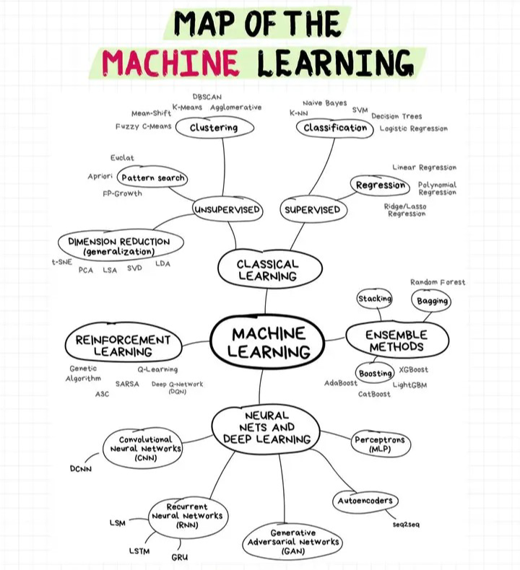
Figure 1: Machine Learning Techniques and Algorithms

The figure below shows the tasks that each ML learning technique associates with.
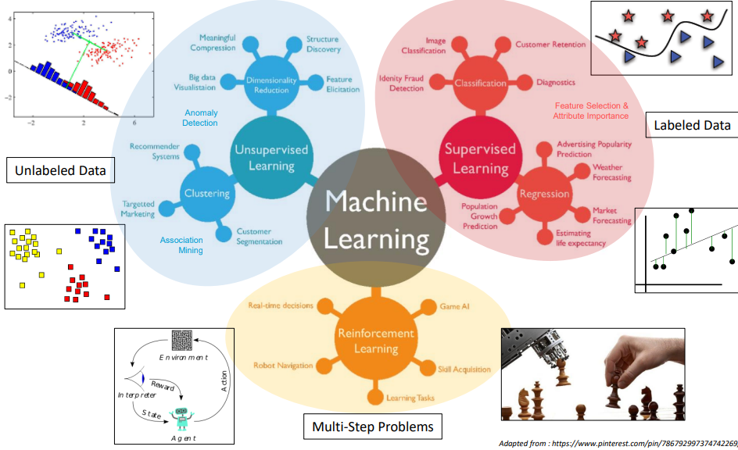
Figure 2: Learning Tasks Associate to Techniques

In addition, to the mentioned ML learning, techniques there is also Ensemble Learning. Ensemble learning is the combination of weak learners so to produce an optimal model that capable of learning and designing rules that each of the weak learners is not capable to learn on their own. The need of ensemble has proven to exist since the state-of-the-art model are lacking and prone to making errors so in order for us to mitigate that we need to combine the weak learners either sequentially of parallel and come up with the one model that is very efficient in solving the problem.
Ensemble learning is embedded in some algorithms like support vector machines but it can be used in processes like bagging, boosting and stacking. These methods work differently and are trained in different ways to alleviate common problems like variance, bias, under-fitting, over-fitting. That is the good thing about ensemble learning but it is worth noting that this is not always the case as it might make the problems we are trying to solve and more severely.

1.3 Deep Learning Methods

Properties of DL
- Data dependencies. Deep learning algorithms tend to perform much better when there is huge data. On the contrary, they perform poorly on small data and frankly I think it is because they do not learn much patterns.
- Hardware dependencies. Large computational capabilities are needed for training a deep learning model. To solve this hurdle, it is wise to outsource to Google Collaboratory or any other web integrated development environment.
- Feature engineering. The feature engineering process is automated for deep learning algorithms. The algorithm is capable of extracting vital features from the raw data using domain knowledge.
- Time. It typically takes a lot of time to train the models that are created using deep learning algorithms.
- Black-box perception and interpretability. It is quite difficult to explain how a DL result was obtained whereas in the state-of-art machine learning it is usually rule based.

A typical neural network that is mainly composed of many simple, connected processing elements/processors called neurons which have excellent learning capabilities. Deep learning uses the concept of neural networks which are found on the human brain and we can map some of the features between the human brain and the neural network.
- Dendrite inputs
- Cell nucleus nodes
- Synapse weights
- Axon output

DL has four categories which are:
- Discriminative Learning
- Generative Learning
- Hybrid Learning
- Deep reinforcement learning
Deep learning can be applied to structured, semi-structure and even unstructured data and some of the data can be said to be either of the following. It has the capability to select the features that are dominant in making the prediction so it does not take into account what kind of data I fed to it.
- Sequential data
- Image/2D data
- Tabular Data
In the general sense the DL process can have three major steps and each of which have sub-steps and that is called the workflow to solve real-world problems.
- Step 1: Data understanding and pre-processing.
This step has a huge effect on the predictive power of the model that is trained more especially the data pre-processing part. The algorithms or models of deep learning prefer data to be in a certain way so the pre-processing part is vital. Other steps within this are:
- Data collection
- Data annotation
- Data pre-processing and augmentation
- Visualization
- Testing simple tasks to get information and insights

- Step 2: Deep learning model building and training
Under this step we need to understand the problem at hand and then understand the learning type to use and we can choose from discriminative, generative and/or hybrid learning.
After understanding what the problem needs, we can then conclude as to which task is it. The available tasks are regression, classification, detection, pattern recognition, descriptive, decision making and clustering. Each of these tasks require a unique approach to the problem.
Some deep learning algorithms that we can utilise for the above task include the following:
- Convolutional Neural Networks
Convolutional neural networks are designed to simulate the visual cortex of a human brain. This is a discriminative deep learning architecture that learns directly from inputs without human intervention, in terms of feature extraction. Each layer on the CNN takes into account optimum parameters for meaningful outputs as well as reducing model complexity. Intended to deal with 2D shapes and thus widely employed in visual recognition, natural language processing, and many more subset fields.
CNN also uses a dropout that can deal with the problem of over-fitting, which is caused in many artificial neural networks. The dropout is embedded on its architecture and thus it does not have to be explicitly put.
There are some variants, which can be used in various application domains depending on their learning capabilities, of CNN are;
- Visual geometry group
- AlexNets
- Xception
- Inception
- ResNets
Convolution neural networks have multiple layers that extract and process features from data and they are:
- Convolution layer
In Keras, it is called the Conv2D. it performs the convolution operation. It is a set of learnable filters that we use to slide over the images spatially, computing dot products between the entries of filters and input image. It can increase the classification performance since the more features are learnt on the images the more we differentiate between the predictor classes. It can be used as the input layer of the sequential model, thus taking the input shape and the activation function. You can add as many convolution layers as you wish.
One thing that the filters should extend to the depth of the image. For example, if we want to apply a filter of size 5x5 to a coloured image of size 32x32, then the filter should have depth 3 (5x5x3) to cover all 3 colour channels. These filters will activate when they see same specific structure.
- Pooling layer
The MaxPooling2D is a form of non-linear down sampling. The goal is to progressively reduce the spatial size of the representation to reduce the amounts of parameters and computation in the network and hence control the overfitting. We can also add the Flatten layer before the fully connected layer to take the inputs from a two dimension into one dimension.
Pooling is often applied with filters of size 2x2 applied with a stride of 2 at every depth slice. A pooling layer of size 2x2 with stride of 2 shrinks the input image to a 1/4 of its original size
- Fully connected layer
These are the normal Dense layers of the deep learning network and they reduce the dimensionality. It uses a 2*2 matrix and that will output ¼ of the input image. The dense layers take units and activation functions as their arguments. You can also add as many Dense layers as you want guided by model accuracy.
Just like any neural network we then need to compile that model so that the backward propagation can work well in terms of adjusting the errors, if any. Before fitting the model, the data that is going to be used in training and testing will need to be prepared and reshaped using the ImageDataGenerator.
During the fitting phase we need to use fit_generator. This function is going to be given the training set, steps_per_epoch which is equal to the number of images on the training set, number of epochs, validation data, which is the test set, and validation steps, which is equal to the number of images on the test set. Know that the training process will definitely take a lot of time if the number of images is huge.

- Multilayer Perceptron
This is a discriminative or supervised deep learning algorithm which is a type of a feed-forward neural network. It is the foundation of deep neural networks as far as the architecture is concerned. A typical multilayer perceptron is a fully connected network, meaning that the neurons of the previous layer all connect to those of the next layer, that consists of input layer – taking all the features, set of hidden layers – and we can only have one layer, as well as an output layer that makes the decision or prediction about the input features. The number of neurons to be used in a layer – dense, are called the units.
The MLP uses activation functions to decide which neurons should be activated. During the training session, it employs back propagation which is a supervised learning technique that is used once the predicted output has found to differ from the actual value. The magnitude of the difference determines how the weight are to be assigned again. This works more like the ensemble boosting technique where the weight of the incorrectly assigned values are given higher values so that they can be boosted by the next weak learner on the sequence.
The MLP network also uses optimization approaches during the training process and these include:
- Stochastic gradient descent
- Adaptive moment estimation
- Backward propagation
- Limited memory BFGS
- More can be found from tensorflow-kseras
These optimizers are used when the model is being compiled and they work in readjusting the weights.
Models are a combination of many parameters and it is difficult to find the best set of them when building the model and thus we have a step for tuning them which is called the hyperparameter tuning. This step can be done manually or automatically with the help of tools like KerasTuner and Random Search. The parameters that are used when building this network comprise of:
- Units
- Layers
- Activation function per layer
- Learning rate
- Epochs
- Metrics

- Recurrent Neural Networks and its Variants
Recurrent neural networks are used for data that is organised and the order is vital because the output of the previous step feeds to the following one.
- Generative Adversarial Network
- Autoencoders and its Variants
This is an umbrella for variants like:
- Sparse AE
- Denoising AE
- Contractive AE
- Variational AE

- Self-organising Map
- Restricted Boltzmann Machine
- Deep Belief Network
- Hybrid Model_1
- Hybrid Model_2
- Hybrid Model_3
- Deep transfer learning
This is a technique for effectively using previously learned model knowledge to solve a new task with minimum training or fine tuning. This is used to solve the problem that is associated with deep learning models where huge amounts of data are needed to effectively train the model. The knowledge that was previously learned by the model and is now used in the new model must be of the same domain thus you cannot use medical data to solve churning. Deep transfer learning also alleviates the demand for high computational capabilities from the computer that is used when training the model.
Transfer learning is a two-stage approach for training deep learning models that consist of a pretraining step and a fine-tuning step in which the model is trained on the target task. Deep transfer learning can be classified into four categories which are:
- Instances based deep transfer learning that utilizes instances in source domain by appropriate weight.
- Mapping based DTL that maps instances from two domains into a new data space with better similarities.
- Network based DTL that reuses the partial network pre-trained in the source domain.
- Adversarial based DTL that uses adversarial technology to find transferable features that both suitable for two domains. Mostly used.
Deep transfer learning can also be classified into inductive, transductive, and unsupervised transfer learning depending on the circumstances between the source and target domains and activities.
The algorithms can be easily viewed from the image below.
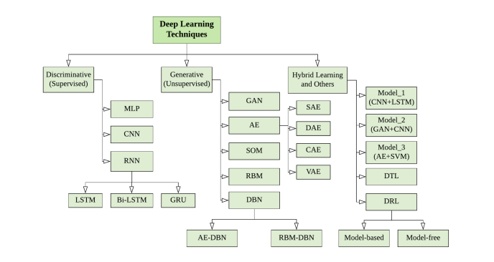
Figure 3: Deep Learning Techniques and Algorithms
It is very important to tune the hyperparameters of the algorithm that you have chosen for task and this can be automatically done by exploiting the KerasTuner from Tensorflow.
- Step 3: Validation and Interpretation
This is a step that include performance analysis and model interpretation and conclusion drawing. From here we can then be able to deploy them model and then use it in either a Narrow AI or Strong General Intelligence application.

1.5 Descending into Machine Learning
It is always easy to start with learning the simple learning algorithms of machine learning so that you can get to appreciate how the whole process goes about and it will be easy to adopt the most complex algorithms. The easiest algorithm can be thought to be linear regression as it is very associated to the mathematics which was instilled in school.
Linear regression is a method for finding the straight line or hyperplane that best fits a set of points plotted on a x and y plane. On the x-axis we have the input data/features and on the y-axis, we have the target values or the label. The model is represented by the hyperplane which is a linear formula which is Y’ = w₁ x₁ + b. where:
- Y’ is the label
- w₁ is the weight or slope of the line
- x₁ is the feature
- b is the bias or y-intercept
To infer Y’ for the new x₁, we must substitute the x₁ value into the model or the equation. Although this model uses only one feature, a more sophisticated model might rely on multiple features, each having a separate weight and that means that the model will have multiple weights and multiple features. The feature of feature of each data input multiplies the weight of that corresponding data input and the bias is always one as there could only be one y-intercept of a linear graph.
The relationship between the features and the label is linear and that means we can be able to draw a straight line to approximate the relationship. There are some plots that coincides with the hyperplane and those are said to have zero loss.
Loss is a penalty of a bad prediction. That is, loss is a number indicating how bad the model’s prediction was on a single example. If the model prediction is perfect, the loss is zero, otherwise, the loss is a greater value which is always positive. The goal of training is to find a set of weights and biases that have low loss, on average. If the prediction is far apart from the actual value, then the loss is greater – plots away from the hyperplane.
We can calculate the loss on a single example by using the squared loss which is also called the L₂ loss. The mean squared error – MSE, is the average squared loss per example over the whole dataset. To calculate the MSE, sum up the squared losses for individual examples and then divide by the number of examples on the dataset.
1.5 Overfitting and Underfitting
Sometimes when we train the model and make predictions, we may see that the model is over or underfitting. These are caused by the model not getting the optimal balance between bias and variance.
An overfit model is explained as having high variance and low bias on the training set and that leads to poor generalization on the testing data. Variance is how much a model changes in response to the training data and bias is the flipside of variance as it represents the strength of our assumptions we make about our data.
When a model is overfit it learns perfectly on the training data such that on evaluation it gives you a perfect score but when you are now making predictions with the previously unseen data, the model predicts them wrongly. An overfit model does a good work during training ang performs poorly on prediction.
Reasons for overfitting include the following.
- Data used in training is not clean
- High variance
- Size of training data is not enough
- The model is too complex
An underfit model is one that has low variance and high bias. When a model is underfit it ignores the lessons from the training data and fails to learn the underlying relationships between input and output.
Reasons for underfitting include the following.
- High bias
- The model is very simple
- Data used in training is not clean
- Size of the training data is not enough
To find the optimal balance between variance and bias, we would want to adopt validation. Ideally, we would have a pre-test set to evaluate the model and make improvements before the real test. This pre-test set is known as the validation set and it is a critical part of model development as it is used for hyperparameter tunning. When we evaluate the model, we get the evaluation and from there we may want to adjust the parameters of the learning algorithm such that it becomes better.
In data science, we use numerous validation-sets because otherwise we would end up with an overfitting model when we are evaluating the model with only one set. During the hyperparameter tuning stage it is possible that we perform the process several times and thus we are only going to be using the same set and that will lead to the model learning the same patterns and giving a bias so it is important to use concepts of cross-validation.

Reinforcement learning
The idea of reinforcement learning can be adopted for many reasons and some of those are likely to include the following:
- Training a machine learning model requires a lot of data, especially when using the deep learning approach of learning, and that might not always be available to us.
- Further, the data that may be provided might not be reliable and thus leading to a model that is not going to be optimal for the problem. Here we are only going to learn a portion of the problem’s solution and thus not expanding to all the possible solutions that may be used to solve the problem
So, the following are the characteristics of reinforcement learning that are used as an advantage;
- No predefined data is needed
- No supervision necessary
- Follows a trial-and-error problem solving approach
- Used to solve reward-based problems
- The machine learns from the environment using rewards and errors

Important concepts in reinforcement learning
- Agent
- Environment
- Actions
- State
- Policy
- Reward
- Exploration
- Exploitation
Markov’s Decision Process
This is a reinforcement learning policy used to map a current state to an action where the agent continuously interacts with the environment to produce new solutions and receive rewards.

